PROFESSIONAL TRAINING REPORT
at
Sathyabama Institute of Science and Technology
(Deemed to be University)

Submitted in partial fulfillment of the requirements for the award of
Bachelor of Engineering Degree in

Computer Science and Engineering
By

BHARAT MUNDHRA (36110166)



DEPARTMENT OF COMPUTER SCIENCE AND ENGINEERING
SCHOOL OF COMPUTING
SATHYABAMA INSTITUTE OF SCIENCE AND TECHNOLOGY
JEPPIAAR NAGAR, RAJIV GANDHI SALAI,
CHENNAI – 600119. TAMILNADU.

APRIL 2019


SATHYABAMA
Institute of Science and Technology
(Established under Section 3 of UGC Act, 1956)
Jeppiaar Nagar, Rajiv Gandhi Salai, Chennai - 600119
www.sathyabamauniversity.ac.in
________________________________________________________________

SCHOOL OF COMPUTING

BONAFIDE CERTIFICATE

This is to certify that this Professional Training Report is the bonafide work of BHARAT MUNDHRA (Reg. No. 36110166) who underwent the professional training in “ONLINE REGRESSION CALCULATOR” under our supervision from February 2019 to March 2019.

Internal Guide
Ms. B. KEERTHI SAMHITHA, M.Tech.,

Head of the Department
Dr. S. VIGNESHWARI, M.E., PhD.,

Submitted for Viva voce Examination held on_____________________

Internal Examiner External Examiner
DECLARATION

I, BHARAT MUNDHRA (Reg. No. 36110166) hereby declare that the Professional Training Report on “ONLINE REGRESSION CALCULATOR” done by me under the guidance of Ms. B. KEERTHI SAMHITHA, M.Tech., at Sathyabama Institute of Science and Technology is submitted in partial fulfillment of the requirements for the award of Bachelor of Engineering degree in Computer Science and Engineering.

DATE:
PLACE: SIGNATURE OF THE CANDIDATE

ACKNOWLEDGEMENT

I am pleased to acknowledge our sincere thanks to Board of management of SATHYABAMA for their kind encouragement in doing this project and for completing it successfully. I am grateful to them.

I convey my thanks to Dr. S. Vigneshwari, M.E., PhD., Department of Computer Science And Engineering for providing me the necessary support and details at the right time during the progressive reviews.

I would like to express our sincere and deep sense of gratitude to our Project Guide Ms. B. Keerthi Samhitha, M.Tech., for her valuable guidance, suggestions and constant encouragement paved way for the successful completion of my project work.

I wish to express my thanks to all Teaching and Non-teaching staff members of the Department of COMPUTER SCIENCE AND ENGINEERING who were helpful in many ways for the completion of the project.

TRAINING CERTIFICATE

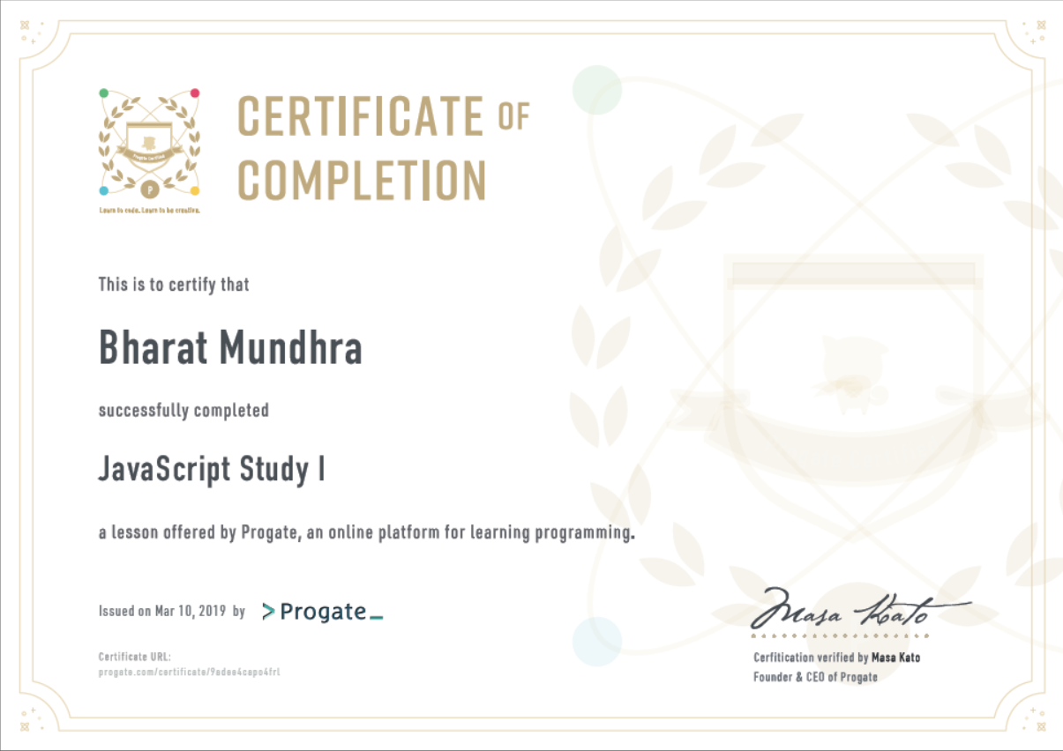
ABSTRACT

Studies of the everyday uses of technology have tended to calculator and, particularly for large calculations. A calculator is a device that performs arithmetic operations on numbers. The simplest calculators can do only addition, subtraction, multiplication, and division. More sophisticated calculators can handle exponential operations, roots,logarithms, trigonometric functions, and hyperbolic functions. Internally, some calculators actually perform all of these functions by repeated processes of addition. This online calculator is specially for solving the regression problem which is a most common concepts of machine learning.It also performms some other related calculations. Though, there are ample online calculator for these calculations, but calculator which combines all these calculations with graph plot is hard to find.Since there are lots of datasets with huge amount of data which cannot be easily calculated manually. It takes ample of time to calculate even with normal calculators. So this online calculator solve this problem of calculating large data manually, making it easier, quicker, and more efficient to continue repeating the same things for different dataset we have. This will be very much helpful and making available new and better ideas. For instance, graphing equations is an important skill in Algebra, but once students have mastered it, it won’t always be necessary to graph everything by hand. Letting the calculator do the heavy lifting can help students make observations about graphs and form connections between the equation, table and graph. It reduces lots of time consumption and increases speed and efficiency.
TABLE OF CONTENTS

Chapter No. Title Page No.

ABSTRACT vi

LIST OF FIGURES ix
1 INTRODUCTION 1
1.1 AIM 1
1.2 SCOPE 1
1.3 GOALS 2
1.4 OBJECTIVES 2
1.5 OUTLINE OF THE PROJECT 2

2. PROJECT PLANS AND REQIREMENTS 3
2.1 PLANS 3
2.2 REQIREMENTS 3
2.3 DESIGN 4
2.4 DEVELOPMENT AND CODING 5
2.5 TESTING 5

3. BRIEF ABOUT HTML5,CSS3 AND JAVASCRIPT 6
3.1 HTML5 6
3.2 CSS3 7
3.3 JavaScript 8

4. DESIGN AND IMPLEMENTATION 9
4.1 DESIGN 9
4.1.1 Pages 9
4.1.3 Tags used for creating webpage 10
4.1.3 Style attributes used for html tags 11

Chapter No. Title Page No.

4.2 IMPLEMENTATION AND CODING 12
4.2.1 Implementation 12
4.2.2 Coding 12

4.3 SCREENSHOTS OF WEBPAGES 26
4.3.1 Mean Calculation Page 26
4.3.2 Slope-Intercept Page 26
4.3.3 Plot For Equation 27
4.3.4 Linear Regression Page 1 27
4.3.5 Linear Regression Page 2 28
4.3.6 Distance-Midpoint Page 28

5. SUMMARY AND CONCLUSION 29
5.1 SUMMARY 29
5.2 CONCLUSION 29

REFERENCES 30

LIST OF FIGURES
Figure No. Title Page No.
4.1 Home Page 9
4.2 Mean Calculation Page 26
4.3 Slope-Intercept Page 26
4.4 Plot Equaiton Page 27
4.5 Linear Regression Page 27
4.6 Regression Calculation Page 28
4.7 Distance and mid point Page 28

CHAPTER 1
INTRODUCTION

A calculator is a device that performs arithmetic operations on numbers. The simplest calculators can do only addition, subtraction, multiplication, and division. More sophisticated calculators can handle exponential operations, roots,logarithms, trigonometric functions, and hyperbolic functions. Internally, some calculators actually perform all of these functions by repeated processes of addition. The calculator currently involves a home page and 6 web pages for statistical functions, 4 of these are directly for spatial analysis. The calculator does not demand any client-side installation other than a web browser. Input data and the parameters set by the user are transferred to the server, which responds with computation results to the client's browser. The calculator has no extra demands on the memory or processing unit of the client's device except for data transfer and browsing ability. Data input to most functions must be pure Cartesian coordinates and variable values. The values should be seperated with commas. Empty cells are not allowed. Coping of data in the textfield is possible. The web pages of the calculator functions also include buttons for viewing a scatter plot of input data. Pressing the button labelled "Calculate" initiates calculation.

1.1 AIM
The aim of this calculator is to make it easier, quicker, and more efficient to continue repeating the same things for different dataset we have, rather than calculating the large dataset manually.

1.2 SCOPE
Some of the project’s scope are :
- Increased efficiency in calculation results.
- Reducing large amount of time from manual calculations
- Building interaction and easy to use
- Give knowledge about the calculation process
1.3 GOALS
The goal of the project is to deliver knowledge about the calculation process in a better and interactive way and to make them use to with the calculator. Also, for reducing time and increasing efficiency

1.4 OBJECTIVES
The main focus is on making it easier, quicker, and more efficient to continue calculating the same things in an interactive way we have This will be very much helpful and making available new and better ideas. Technology can support learning by facilitating, exploration and analysis of information.
Simulation of events or processes, visualization of abstract concepts, manipulation of variables, construction of knowledge, practice and drilling of skills are needed for the project.
Finally, while information does not equal knowledge and technology is not a thoughtful, meaningful, and authentic. Integration of technology and information resources can enhance learning and lead to development of knowledge.

1.5 OUTLINE OF THE PROJECT
The project describes the online calculator used for calculating regression problem with some other related calculation. The project is all about learning and making it easier to calculate for large dataset. By this, they can solve the problem, save time for manual calculation and gain knowledge. They can calculate mean values, slope, intercept, midpoints, distance for a line and can solve regression problem for large dataset. Even they can plot any equation easily.
CHAPTER 2
PROJECT PLANS AND REQUIREMENTS

2.1 PLANS
Planning is important before starting the project. It ensures that there's a proper plan for executing on strategic goals. The plans created before starting the project helps to manage time, cost, quality, change, risk and issues.
The plans for this project are as follows:
1. Analysing the project’s objectives
2. Collection of reqirements for the project
3. Designing the webpage using HTML5
4. Adding interactive designs using CSS3
5. Writing JavaScript for calculations
6. Getting the input from users
7. Displaying the expected output
8. Testing
9. Deployment

2.2 REQIREMENTS
The materials and components needed for the project are gathered or collected. It consists of three primary steps: taking inventory of the materials and components on hand, identifying which additional ones are needed and then scheduling their production.
The reqirements for this project are as follows:
1.Collection of images used in the web page.
2.Collection of audios used for buttons.
3.Collection of formulas for calculations.
4.Collection of information for every calculations.

2.3 DESIGN
For the purposes of this project, "design" means the visual design of the site as well as the implementation details that underlie it. The design document should describe what the finished site will look like and how you will make it work.
An important part of the design will be a set of mockup images: pictures of what you want each page to look like or perhaps of common elements such as the logo. The final product of the design phase is a webpage that contains a structured essay - a combination of text and images of your mockup pages.
The document (webpage) should contain these components:
1. Header: A title, type of the document.
2. Navigation Structure: A brief about the site's navigation structure using some terminology. It is a map or description of which pages connect to which other pages.
3. Page Layout and Appearance: A description of design decisions that are universal to the site. It should specify in writing the fonts (types and sizes), the color scheme (for text, background, links, shadows, borders, etc.), navbar position in the page and its appearance, banner, footer, the social icons bar, or background images (if any of them is applicable).
4. Content: This is the longest section of the document. For every page, it needs to give a text description of the content of the page as well as an image of the mockup of the page. The text describes what goal(s) this page fulfills, and how design decisions specific to it contribute into fulfilling such goals.
5. Plan: A clear, specific description of the plan for building the site is provided. Outline the tasks to be accomplished. Include a list of files and folders, which will help each link to file has built. Include a complete list of everything need to get from the users (text, pictures, sound, etc.).
2.4 DEVELOPMENT AND CODING
Building of web page is started according to the design made for the page. Design of the page is carefully followed and assembled. HTML5 and CSS3 are used to create the webpage, provided JavaScript for calculation purpose.
Hypertext Markup Language (HTML) is the standard markup language for creating web pages and web applications. Web browsers receive HTML documents from a web server or from local storage and render the documents into multimedia web pages. HTML describes the structure of a web page semantically and originally included cues for the appearance of the document. HTML elements are delineated by tags.
CSS Style sheets are used to define font faces, styles, sizes and colors for consistency throughout the site. It also makes it very easy to change styles, fonts and colors, site-wide, with only a few minor changes in the style sheet. CSS has a simple syntax and uses a number of English keywords to specify the names of various style properties. A style sheet consists of a list of rules. Each rule or rule-set consists of one or more selectors, and a declaration block.
JavaScript (JS) is a lightweight, interpreted or JIT compiled programming language with first-class functions. Most well-known as the scripting language for Web pages, many non-browser environments also use it, such as node.js and Apache CouchDB.

2.5 TESTING
Web Testing in simple terms is checking the web application for potential bugs before its made live or before code is moved into the production environment. Testing all links in the webpages working correctly and making sure there are no broken links. Testing the site Navigation, Menus, buttons or Links to different pages on the page and ensure that it should be easily visible and consistent on all webpages.
CHAPTER 3
BRIEF ABOUT HTML5 AND CSS3

3.1 HTML5
The first thing to realize about HTML5 is, it's not a single entity. It's comprised of many elements, including the fifth revision of HTML, CSS3 and many JavaScript API's. It allows you to use the multimedia experience of the desktop on the web. With HTML5, developers can create apps and websites that function like desktop applications, which allows us to use the web platform to reach all of your users at once. An interesting aspect of HTML5 is that it will allow us to create apps that function even when not connected, or when your system is offline.
With HTML5, we can make use of a wide variety of graphics elements, such as animation, games, movies, etc. Even intense graphics effects such as lightning and shadows, 3D, special effects, vector graphics and so on are supported. A major advance is with the JavaScript engines, which are fast enough to run these applications in real time. Hardware accelerated rendering is being used in modern browsers to create smooth rendering and transitions. What this means is that browsers are using the GPU (Graphics Processing Unit) to speed up computing tasks, which will improve the user experience.HTML5 tags are backwards compatible so that HTML 4-based content won't destroy HTML5 content. The former HTML structure and formatting is retained.
Several new tags have been added, some of which are: <audio> is used for sound, <video> for video playback, <canvas> for dynamic graphics. HTML5 allows SVG and MathML graphics to be embedded inline or linked within the HTML content. The result is that developers can include complex imagery without images, nor do they need to rely on third party platforms.
All of the major browsers (Safari, Chrome, Opera, Internet Explorer) support HTML5, but it's not equal across platforms, so it's important to test out the features on the different devices, platforms, etc. To make sure that you're obtaining the results you seek, it would be wise to get feedback from users during the course of development.
3.2 CSS3
Cascading Style Sheets (CSS) is a style sheet language used for describing the presentation of a document written in a markup language like HTML. CSS is a cornerstone technology of the World Wide Web, alongside HTML and JavaScript.
CSS is designed to enable the separation of presentation and content, including layout, colors, and fonts. This separation can improve content accessibility, provide more flexibility and control in the specification of presentation characteristics, enable multiple web pages to share formatting by specifying the relevant CSS in a separate .css file, and reduce complexity and repetition in the structural content.
Separation of formatting and content also makes it feasible to present the same markup page in different styles for different rendering methods, such as on-screen, in print, by voice (via speech-based browser or screen reader), and on Braille-based tactile devices. CSS also has rules for alternate formatting if the content is accessed on a mobile device.
The name cascading comes from the specified priority scheme to determine which style rule applies if more than one rule matches a particular element. This cascading priority scheme is predictable.
In addition to HTML, other markup languages support the use of CSS, including XHTML, plain XML, SVG, and XUL.CSS has a simple syntax and uses a number of English keywords to specify the names of various style properties. A style sheet consists of a list of rules. Each rule or rule-set consists of one or more selectors, and a declaration block.CSS, selectors declare which part of the markup a style applies to by matching tags and attributes in the markup itself.
The style sheet with the highest priority controls the content display. Declarations not set in the highest priority source are passed on to a source of lower priority, such as the user agent style. This process is called cascading.

3.2 JAVASCRIPT
JavaScript often abbreviated as JS, is a high-level, interpreted programming language that conforms to the ECMAScript specification. It is a programming language that is characterized as dynamic, weakly typed, prototype-based and multi-paradigm.
Alongside HTML and CSS, JavaScript is one of the core technologies of the World Wide Web. JavaScript enables interactive web pages and is an essential part of web applications. The vast majority of websites use it, and major web browsers have a dedicated JavaScript engine to execute it.
As a multi-paradigm language, JavaScript supports event-driven, functional, and imperative (including object-oriented and prototype-based) programming styles. It has APIs for working with text, arrays, dates, regular expressions, and the DOM, but the language itself does not include any I/O, such as networking, storage, or graphics facilities. It relies upon the host environment in which it is embedded to provide these features.
Initially only implemented client-side in web browsers, JavaScript engines are now embedded in many other types of host software, including server-side in web servers and databases, and in non-web programs such as word processors and PDF software, and in runtime environments that make JavaScript available for writing mobile and desktop applications, including desktop widgets.
Although there are similarities between JavaScript and Java, including language name, syntax, and respective standard libraries, the two languages are distinct and differ greatly in design. JavaScript was influenced by programming languages such as Self and Scheme.
CHAPTER 4
DESIGN AND IMPLEMENTATION

4.1 DESIGN
4.1.1 Pages
- Home Page –
All types of calculation are given in the form of buttons.

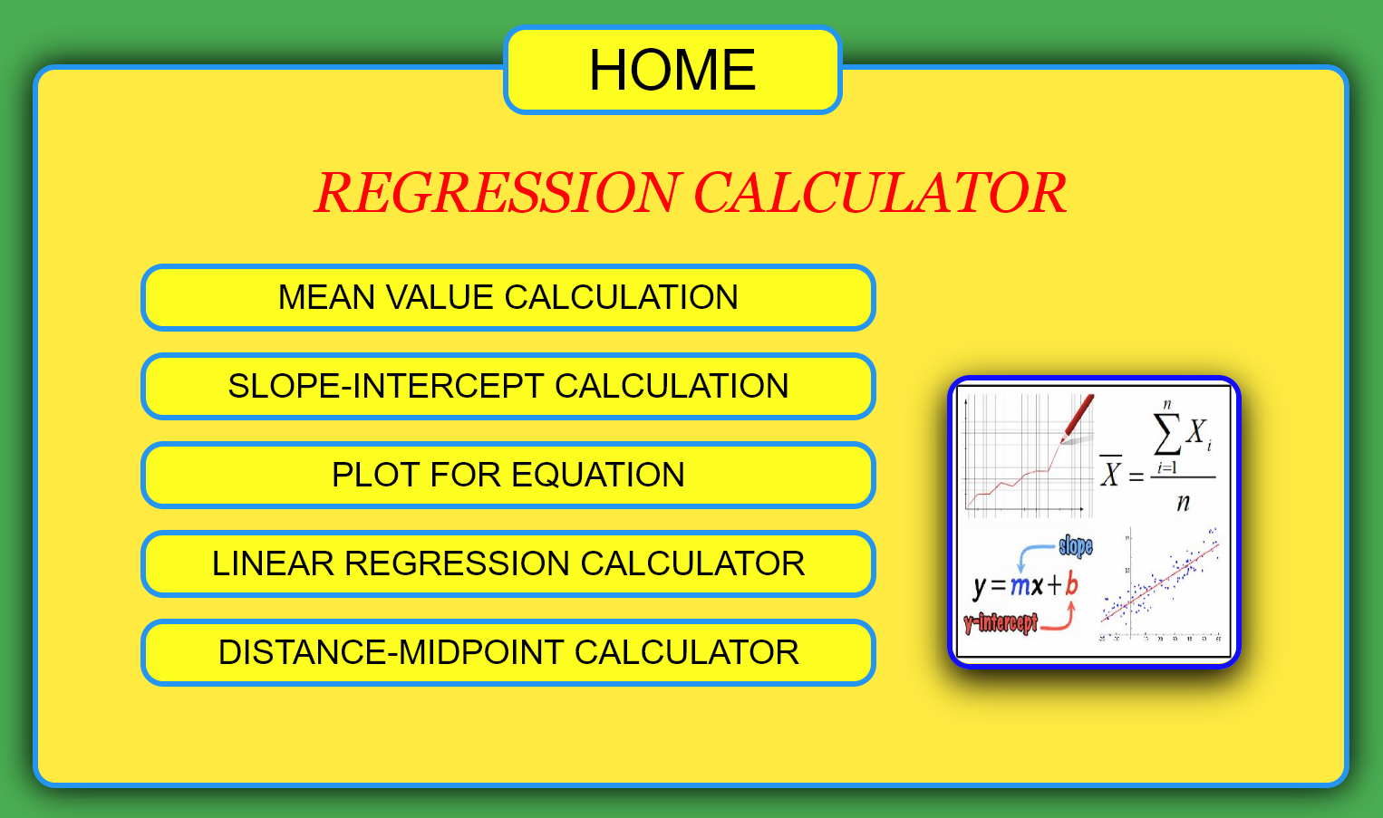
Figure 4.1 – Home Page

- Mean Calculation Page –
The mean, most commonly known as the average of a set of numerical alues, is a measure of central tendency, a value that estimates the center of a set of numbers.
∑(x₁,x₂,x₃,….,x_{n})
Mean = ____________________
n
- Slope-Intercept Page –
The term slope is the inclination, or gradient, of a line. It tells us how much y changes for a fixed change in x. If it is positive, the values of y increase with increasing x. If it is negative, y decreases with an increasing x.
( y₂ – y₁)
Slope = ____________ Intercept = y₂ – (slope * x₂)
( x₂ – x₁)
- Plot for Equation Page –
Plotting is used for analysing the equation behaviour and its curve.On typing the equation in the textfield and clicking on DRAW button, the graph cab be generated.For example, y= 0.6x+3.5 , y = sin(x+3)+2,etc.

- Linear Regression Page –
This simple linear regression calculator uses the least squares method to find the line of best fit for a set of paired data, allowing you to estimate the value of a dependent variable (Y) from a given independent variable (X).
y = slope * x + intercept
- Distance-Midpoint Page –
To find the exact length between 2 co-ordinates (x1, y1) & (x2, y2) in the XY plane or two dimensional geographical co-ordinate system, by applying pythagoras theorem. According to the rule of right triangle, squared hypotenuse is equal to the sum of the squares of the other two sides. The same formula is applied in this distance calculator to find the length between the two given coordinates (x1, y1) and (x2, y2) in the XY plane.
____________________________
Distance = √(x₁+x₂)²+(y₁+y₂)²

4.1.2 Tags used for creating webpage
• <html> - Defines an HTML document
• <head> - Defines information about the document
• <title> - Defines a title for the document
• <body> - Defines the document's body
• <ul> - Defines an unordered list
• <li> - Defines a list item
• <a> - Defines a hyperlink
• <br> - Inserts a single line break
• <img> - Defines an image
• <center> - Defines centered text
• <div> - Defines a section in a document
• <audio> - Defines sound content
• <source> - Defines multiple media resources for media element

4.1.3 Style attributes used for html tags
- background-color – Specifies the color of background of the page
- position – Specifies the type of positioning method
- left – Set the left edge of a positioned element
- float – Specifies how an element should float
- display – Specifies the display behavior of an element
- padding – Set the space between its content and its border
- text-decoration – Specifies the decoration added to text
- font-size – Specifies size of the text
- color – Specifies color of the text
- href – Specifies the link's destination
- onMouseOver – Fires when the mouse pointer moves over an element
- onMouseOut – Fires when the mouse pointer moves out an element
- height – Specifies the height of the text
- width – Specifies the width of the text
- margin-top – Specifies the top margin of text or images
- border – Specifies the border of text or images
- border-radius – Specifies the curves of the border of the corners
4.2 IMPLEMENTATION AND CODING
4.2.1 Implemention
- Backgroung Colour or Image
- Font Style, Colour and size
- Margin and Alignment
- Images
- Audio
- Buttons
- Links
- Graphs
- Scripting and Calculations

4.2.2 Coding
Webpages(HTML) :

For home page :
<html>
<head>
<link rel="stylesheet" href="lig.css">
</head>
<body>
<div id="container">
<center><a href="home.html"><button id="home" onmouseover="p()" onmouseout="p()">HOME</button></a></center>
<header><center>REGRESSION CALCULATOR</center></header><br>
<div id="links">
<ul>
<li><a href="mean.html"><button class="link" onmouseover="i1()" onmouseout="aa()">MEAN VALUE CALCULATION</button></a></li><br>
<li><a href="slope.html"><button class="link" onmouseover="i2()" onmouseout="aa()">SLOPE-INTERCEPT CALCULATION</button></a></li><br>
<li><a href="plot.html"><button class="link" onmouseover="i3()" onmouseout="aa()">PLOT FOR EQUATION</button></a></li><br>
<li><a href="index.html"><button class="link" onmouseover="i4()" onmouseout="aa()">LINEAR REGRESSION CALCULATOR</button></a></li><br>
<li><a href="dist.html"><button class="link" onmouseover="i5()" onmouseout="aa()">DISTANCE-MIDPOINT CALCULATOR</button></a></li><br>
</ul>
<img src="./img/all.jpg" id="img">
<audio id="sound">
<source src="./img/sound.mp3" type="audio/mpeg">
</audio>
</div>
<script>
var audio=document.getElementById("sound");
function p(){audio.play();}
function aa(){document.getElementById("img").src="./img/all.jpg";audio.play();}
function i1(){document.getElementById("img").src="./img/mean.jpg";audio.play();}
function i2(){document.getElementById("img").src="./img/slope.jpg";audio.play();}
function i3(){document.getElementById("img").src="./img/graph.jpg";audio.play();}
function i4(){document.getElementById("img").src="./img/reg.jpg";audio.play();}
function i5(){document.getElementById("img").src="./img/dist.jpg";audio.play();}
</script>
</body>
</html><marquee direction="down" width="25%"><img src="..\img\num.png"

For mean page :
<html>
<head>
<link rel="stylesheet" href="lig.css">
</head>
<body>
<div id="container">
<center><a href="home.html"><button id="home" onmouseover="p()" onmouseout="p()">HOME</button></a></center>
<header><center>MEAN VALUE CALCULATION</center></header><br>
<p>The mean, most commonly known as the average of a set of numerical values, is a measure of central tendency,
a value that estimates the center of a set of numbers.</p>
<p>This calculator uses the following formula to calculate the mean:</p>
<h2><center>SUM (x<sub>i</sub>) / n</center></h2>
<p>where <strong>n</strong> is the total number of values and <strong>x<sub>i</sub></strong> (x2, x1, ... ,xn) are the individual numbers in the data set.
In words: It's the sum of all values, divided by the total number of values.</p>
<p>To calculate the mean, enter the numerical values in the box above. You may separate individual values by commas.
You may also copy and paste data into the text box. Press the "Calculate" button to perform the computation.
The mean will be displayed if the calculation is successful.</p>
<div id="input" style="margin-top: 0px;">
<span id="xx">Values : </span>
<textarea type="text" id="val"></textarea>&nbsp;&nbsp;&nbsp;&nbsp;&nbsp;&nbsp;
<span id="xx">Mean Value :</span>
<input type="text" id="mean" value="0">
</div>
<span id="err" style="color:red"></span><br>
<center><button id="cal" onclick="mean()" onmouseover="p()" onmouseout="p()">Calculate</button></center>
<audio id="sound">
<source src="./img/sound.mp3" type="audio/mpeg">
</audio>
</div>
<script>
var audio=document.getElementById("sound");
function p(){audio.play();}
function sum(s){return eval(s.join('+'));}
function mean(){
var v0 = document.getElementById("val").value;
var v1 = v0.split(",");
for(i=0;i<v1.length;i++){
v1[i]=parseInt(v1[i]);
}
var avg = sum(v1)/v1.length;
if(isNaN(avg)){
document.getElementById("err").innerHTML = "*Please Enter Numeric Value Only.";
}
else{
document.getElementById("err").innerHTML = "";
document.getElementById("mean").value = avg;
}

}

</script>
</body>
</html>

For Slope-Intercept page :
<html>
<head>
<link rel="stylesheet" href="lig.css">
</head>
<body>
<div id="container">
<center><a href="home.html"><button id="home" onmouseover="p()" onmouseout="p()">HOME</button></a></center>
<header><center>SLOPE-INTERCEPT CALCULATION</center></header><br>
<p>The term slope is the inclination, or gradient, of a line. It tells us how much y changes for a fixed change in x. If it is positive,
the values of y increase with increasing x. If it is negative, y decreases with an increasing x. </p>
<p>This calculator uses the following formula to calculate the slope:</p>
<h2><center>slope = (y2-y1)/(x2-x1)</center></h2>
<p>where <strong>(x1,y1)</strong> and <strong>(x2,y2)</strong> are the two co-ordinates in a line.</p>
<p>Y-intercept is the value of y at which the line crosses the y-axis.It can be calculated using the formula : </p>
<h2><center>intercept = y1-(slope*x1)</center></h2>
<p>To calculate the slope and intercept, enter the numerical values in the boxes below. Press the "Calculate" button to perform the computation.
The slope and intercept will be displayed if the calculation is successful.</p>
<div>
<span>x1 : </span>

<input type="text" id="x1">&nbsp;&nbsp;&nbsp;&nbsp;&nbsp;&nbsp;
<span>x2 : </span>
<input type="text" id="x2"><br><br>
<span>y1 : </span>
<input type="text" id="y1">&nbsp;&nbsp;&nbsp;&nbsp;&nbsp;&nbsp;
<span>y2 : </span>
<input type="text" id="y2"><br><br><hr><br>
<span>Slope : </span>&nbsp;&nbsp;&nbsp;&nbsp;&nbsp;&nbsp;&nbsp;&nbsp;&nbsp;
<input type="text" id="slope" value="0"><br><br>
<span>Intercept : </span>
<input type="text" id="intercept" value="0"><br>
</div>
<span id="err" style="color:red"></span><br>
<center><button id="cal" onclick="si()" onmouseover="p()" onmouseout="p()">Calculate</button></center>
<audio id="sound">
<source src="./img/sound.mp3" type="audio/mpeg">
</audio>
</div>
<script>
var audio=document.getElementById("sound");
function p(){audio.play();}
function si(){
var x1 = parseInt(document.getElementById("x1").value);
var x2 = parseInt(document.getElementById("x2").value);
var y1 = parseInt(document.getElementById("y1").value);
var y2 = parseInt(document.getElementById("y2").value);
var m = (y2-y1)/(x2-x1);
var c = y1-(m*x1);
if(x1!==x2){
if(isNaN(m)){
document.getElementById("err").innerHTML = "*Please Enter Numeric Value Only.";
}
else{
document.getElementById("err").innerHTML = "";
document.getElementById("slope").value = m;
document.getElementById("intercept").value = c;
}
}else{document.getElementById("slope").value = "Infinity";document.getElementById("intercept").value = x1;}
}

</script>
</body>
</html>

For Plot Graph page :

<!DOCTYPE html>
<html>
<head>
<title>math.js | plot</title>
<script src="math.js"></script>
<script src="plotly.js"></script>
<link rel="stylesheet" href="lig.css">
</head>
<body>
<div id="container">
<center><a href="home.html"><button id="home" onmouseover="p()" onmouseout="p()">HOME</button></a></center>
<header><center>PLOT FOR EQUATION </center></header><br>
<form id="form">
<label for="eq"><p>Enter an equation:</p></label>
<input type="text" id="text" value="y=x" />&nbsp;&nbsp;
<input id="draw" type="submit" value="Draw" onmouseover="p()" onmouseout="p()"/>
</form>

<div id="plott"></div>
<audio id="sound">
<source src="./img/sound.mp3" type="audio/mpeg">
</audio>
</div>
<script>
var audio=document.getElementById("sound");
function p(){audio.play();}
function draw() {
try {
// compile the expression once
const expression = document.getElementById('text').value
const expr = math.compile(expression)

// evaluate the expression repeatedly for different values of x
const xValues = math.range(-10, 10, 0.5).toArray()
const yValues = xValues.map(function (x) {
return expr.eval({x: x})
})

// render the plot using plotly
const trace1 = {
x: xValues,
y: yValues,
type: 'scatter'
}
const data = [trace1]
Plotly.newPlot('plott', data)
}
catch (err) {
console.error(err)
alert(err)
}
}

document.getElementById('form').onsubmit = function (event) {
event.preventDefault()
draw()
}

draw()
</script>

</body>
</html>

For Linear Regression page 1 :
<html>
<head>
<script src="lig.js"></script>
<link rel="stylesheet" href="lig.css">
</head>
<body>
<div id="container">
<center><a href="home.html"><button id="home" onmouseover="p()" onmouseout="p()">HOME</button></a></center>
<header><center>LINEAR REGRESSION CALCULATOR</center></header><br>
<p>This simple linear regression calculator uses the least squares method to find the line of best fit for a set of paired data,
allowing you to estimate the value of a dependent variable (Y) from a given independent variable (X).</p>
<p>The line of best fit is described by the equation ŷ = bX + a, where b is the slope of the line and a is the intercept
(i.e., the value of Y when X = 0). This calculator will determine the values of b and a for a set of data comprising two variables,
and estimate the value of Y for any specified value of X.</p>
<p>To begin, you need to add paired data into the two text boxes immediately below as a comma delimited list,
with your independent variable in the X Values box and your dependent variable in the Y Values box. For example,
if you wanted to generate a line of best fit for the association between height and shoe size, allowing you to predict shoe size on the basis of
a person's height, then height would be your independent variable and shoe size your dependent variable.</p>
<div id="input" style="margin-top: 0px;">
<span id="xx">X Values : </span>
<textarea type="text" id="a"></textarea>
<span id="xx">Y Values : </span>
<textarea type="text" id="b"></textarea>

</div>
<p>This calculator can estimate the value of a dependent variable (Y) for any specified value of an independent variable (X).
Simply add the X values for which you wish to generate an estimate into the Estimate box below as a comma delimited list.
</p>
<div id="input" style="margin-top: 0px;">
<span id="xx">Estimate : </span>
<textarea type="text" id="c"></textarea><br>
</div>
<center><a href="lig.html"><button id="cal" onclick="abc()" onmouseover="p()" onmouseout="p()">Calculate</button></a></center>
<audio id="sound">
<source src="./img/sound.mp3" type="audio/mpeg">
</audio>
</div>
<script>
var audio=document.getElementById("sound");
function p(){audio.play();}
</script>
</body>
</html>

For Linear Regression page 2 :
<html>
<head>
<script src="lig.js"></script>
<script src="math.js"></script>
<script src="plotly.js"></script>
<link rel="stylesheet" href="lig.css">
</head>
<body>
<div id="container">
<center><a href="home.html"><button id="home" onmouseover="p()" onmouseout="p()">HOME</button></a></center>
<header><center>LINEAR REGRESSION CALCULATOR</center></header><br>
<p>For your data, the regression equation for Y is:</p>
<h1 id="eq"></h1><span id="err" style="color:red"></span>
<p>You asked the calculator to estimate a Y value for one or more X values. You'll find the estimated Y values in the Estimated Y text box below.</p>
<p>As you can see the output from this calculator is fairly verbose. Mostly it should be self-explanatory, but you should note that any apparent
discrepancies in calculations are because rounding is used for the purposes of display, but not for the calculations themselves.</p>
<p>If you wish to perform a further calculation, it is necessary to hit the reset button at the bottom of the page.</p>

<div id="input">

<div id="sum">
<center><strong>Summary</strong></center>
xmean : <span id="xmean" style="position:relative;left:0px;top:0px;"></span><br>
ymean : <span id="ymean" style="position:relative;left:0px;top:0px;"></span><br>
intercept:<span id="i" style="position:relative;left:0px;top:0px;"></span><br>
slope :<span id="m" style="position:relative;left:0px;top:0px;"></span><br>
R<sup>2</sup> :<span id="r" style="position:relative;left:0px;top:0px;"></span><br>
MSE :<span id="mse" style="position:relative;left:0px;top:0px;"></span><br>
</div>

<span id="xx">X Values : </span>
<textarea type="text" id="x" style="position:relative;left:40px"></textarea><br>
<span id="xx">Y Values : </span>
<textarea type="text" id="y" style="position:relative;left:40px"></textarea><br>
<span id="xx">Estimate : </span>
<textarea type="text" id="e" style="position:relative;left:44px"></textarea><br>
<span id="xx">Estimated Y : </span>
<textarea type="text" id="Y"></textarea><br>

</div>
</div>

<center><a href="index.html"><button id="reset" onmouseover="p()" onmouseout="p()">RESET</button></a><br></center>
<div id="plot"></div>
<audio id="sound">
<source src="./img/sound.mp3" type="audio/mpeg">
</audio>
<script>
var audio=document.getElementById("sound");
function p(){audio.play();}
document.getElementById("err").innerHTML=window.localStorage.getItem("err");
document.getElementById("xmean").innerHTML=window.localStorage.getItem("xmean");
document.getElementById("ymean").innerHTML=window.localStorage.getItem("ymean");
document.getElementById("eq").innerHTML=window.localStorage.getItem("eq");
document.getElementById("m").innerHTML=window.localStorage.getItem("m");
document.getElementById("i").innerHTML=window.localStorage.getItem("i");
document.getElementById("r").innerHTML=window.localStorage.getItem("r");
document.getElementById("mse").innerHTML=window.localStorage.getItem("mse");
document.getElementById("Y").innerHTML=window.localStorage.getItem("Y");
document.getElementById("x").innerHTML=window.localStorage.getItem("x");
document.getElementById("y").innerHTML=window.localStorage.getItem("y");
document.getElementById("e").innerHTML=window.localStorage.getItem("e");
window.localStorage.clear();
</script>

<script>
draw();
function draw() {
try {
// compile the expression once
const expression = document.getElementById("eq").innerHTML;
const expr = math.compile(expression)

// evaluate the expression repeatedly for different values of x
const xValues = math.range(0, 8, 1 ).toArray()
const yValues = xValues.map(function (x) {
return expr.eval({x: x})
})

// render the plot using plotly
const trace1 = {
x: xValues,
y: yValues,
type: 'scatter'
}
const data = [trace1]
Plotly.newPlot('plot', data)
}
catch (err) {
console.error(err)
alert(err)
}
}

document.getElementById('form').onsubmit = function (event) {
event.preventDefault()
draw()
}

draw()
</script>

</body>
</html>

For Distance-Midpoint page :
<html>
<head>
<link rel="stylesheet" href="lig.css">
</head>
<body>
<div id="container">
<center><a href="home.html"><button id="home" onmouseover="p()" onmouseout="p()">HOME</button></a></center>
<header><center>DISTANCE-MIDPOINT CALCULATION</center></header><br>
<p>to find the exact length between 2 co-ordinates (x1, y1) & (x2, y2) in the XY plane or two dimensional geographical co-ordinate system,
by applying pythagoras theorem. According to the rule of right triangle, squared hypotenuse is equal to the sum of the squares of the other two sides.
The same formula is applied in this distance calculator to find the length between the two given coordinates (x1, y1) and (x2, y2) in the XY plane.
The distance between two point formula, example & calculator helps user to understand, practice and verify such calculations. </p>
<p>This calculator uses the following formula to calculate the distance between 2 points:</p>
<h2><center>distance = &radic;(x2-x1)<sup>2</sup>+(y2-y1)<sup>2</sup></center></h2>
<p>where <strong>(x1,y1)</strong> and <strong>(x2,y2)</strong> are the two co-ordinates in a line.</p>
<p>Midpoint of a line segment is the point on that line segment that divides the segment in two congruent segments. It can be calculated using the formula : </p>
<h2><center>Midpoint = ( (x1+x2)/2 , (y1+y2)/2 )</center></h2>
<p>To calculate the distance and midpoint, enter the numerical values in the boxes below. Press the "Calculate" button to perform the computation.
The distance and midpoint will be displayed if the calculation is successful.</p>
<div>
<span>x1 : </span>
<input type="text" id="x1">&nbsp;&nbsp;&nbsp;&nbsp;&nbsp;&nbsp;
<span>x2 : </span>
<input type="text" id="x2"><br><br>
<span>y1 : </span>
<input type="text" id="y1">&nbsp;&nbsp;&nbsp;&nbsp;&nbsp;&nbsp;
<span>y2 : </span>
<input type="text" id="y2"><br><br><hr><br>
<span>Distance : </span>&nbsp;&nbsp;&nbsp;&nbsp;&nbsp;&nbsp;&nbsp;&nbsp;&nbsp;
<input type="text" id="dist" value="0"><br><br>
<span>Midpoint : </span>
<input type="text" id="mp" value="0,0"><br>
</div>
<span id="err" style="color:red"></span><br>
<center><button id="cal" onclick="dist()" onmouseover="p()" onmouseout="p()">Calculate</button></center>
<audio id="sound">
<source src="./img/sound.mp3" type="audio/mpeg">
</audio>
</div>
<script>
var audio=document.getElementById("sound");
function p(){audio.play();}
function dist(){
var x1 = parseInt(document.getElementById("x1").value);
var x2 = parseInt(document.getElementById("x2").value);
var y1 = parseInt(document.getElementById("y1").value);
var y2 = parseInt(document.getElementById("y2").value);
var dist = Math.sqrt((y2-y1)**2+(x2-x1)**2);
var mp1 = (x1+x2)/2;
var mp2 = (y1+y2)/2;
if(isNaN(dist)){
document.getElementById("err").innerHTML = "*Please Enter Numeric Value Only.";
}
else{
document.getElementById("err").innerHTML = "";
document.getElementById("dist").value = dist;
document.getElementById("mp").value = mp1+","+mp2;
}

}

</script>
</body>
</html>

StyleSheet(CSS):
body{
background-color: #4CAF50;
}

#container{
background-color: #ffeb3b;
border:#2196F3 5px solid;
border-radius: 20px;
width: 70%;
margin: 5% auto;
padding: 50px;
padding-top: 0px;
box-shadow: 0 0 50px 1px;
}

header{
font-size: 50px;
color: red;
font-family: Georgia, 'Times New Roman', Times, serif;
font-style: oblique;
}
p{
font-size: 30px;
font-style: italic;
}

#input{
width: 80%;
margin-top: -230px;
margin-left: 100px;
}

textarea{
height: 200px;
width: 100px;
font-size: 14pt;
}
span{
font-size: 30px;
}

#xx{
position: relative;
bottom: 100px;
}

button{
font-size: 50px;
height: 80px;width: 300px;
background-color: yellow;
border: #2196F3 5px solid;
border-radius: 20px;
}
#cal{
position: relative;
top: 90px;
left: 0px;
}

#reset{
position: relative;
bottom: 120px;
left: 0px;
}

button:hover{
box-shadow: 0 0 50px 1px;
font-size: 55px;
}

#plot{
border: 5px blue solid;
border-radius: 20px;
box-shadow: 0 10px 50px 1px;
position: relative;
width: 400px;
height: 400px;
float: left;
bottom:1050px;
left:750px;
}

#plott{
width: 80%;
border: 5px blue solid;
border-radius: 20px;
position: relative;
top:30px;
}

#plott:hover{
box-shadow: 0 10px 50px 1px;
}
#sum{
background-color: rgb(243, 183, 71);
border: 5px blue solid;
border-radius: 20px;
position: relative;
top:750px;
left:410px;
width: 50%;
font-size: 30px;
padding:10px 5px;
box-shadow: 0 10px 50px 1px;
}

#text,#x1,#x2,#y1,#y2,#slope,#intercept{
height: 40px;width: 400px;
font-size: 20pt;
}

#draw{
font-size:16pt;
height: 45px;width: 150px;
background-color: rgb(243, 240, 71);
border: rgb(52, 38, 248) 3px solid;
border-radius: 10px;
}

#draw:hover{
box-shadow: 0 0 50px 1px;
}

#home{
position: relative;
bottom: 40px;
left: 0px;
}
#mean{
height: 40px;width: 400px;
font-size: 20pt;
position: relative;
bottom: 105px;
left: 10px;
}
.link{
font-size: 30px;
height: 60px;width: 650px;

}
.link:hover{
font-size: 35px;
}
ul{
list-style: none;
}
img{
float: right;
height: 250px;width: 250px;
position: relative;
bottom: 310px;
right: 40px;
border: 5px blue solid;
border-radius: 20px;
box-shadow: 0 10px 50px 1px;
}

JavaScript(JS):

function sum(s){return eval(s.join('+'));}
function abc(){
var s1=document.getElementById("a").value;
var s2=document.getElementById("b").value;
var s3=document.getElementById("c").value;
var x=s1.split(",");
var y=s2.split(",");
var X=s3.split(",");

if(x.length==y.length){
for(i=0;i<x.length;i++){
x[i]=parseInt(x[i]);
y[i]=parseInt(y[i]);
}
xavg=sum(x)/x.length;
yavg=sum(y)/y.length;
if(isNaN(xavg) || isNaN(yavg)){
window.localStorage.setItem("err","*Please Enter Numeric Value Only.")}
else{
var x2=[],y2=[],x3=[],y3=[],xy=[];
for(i=0;i<x.length;i++){
x2.push(x[i]-xavg);
y2.push(y[i]-yavg);
x3.push(x2[i]**2);
y3.push(y2[i]**2);
xy.push(x2[i]*y2[i]);
}
var sx3=sum(x3),sy3=sum(y3),sxy=sum(xy);
var m=sxy/sx3;

var c=yavg-m*xavg;

var yy=[],y4=[],Y=[];
for(i=0;i<x.length;i++){
yy.push(m*x[i]+c);
y4.push((yy[i]-yavg)**2);
}
var sy4=sum(y4);
var R=sy4/sy3;
var mse=Math.sqrt(sy4/(x.length-2));

for(i=0;i<X.length;i++){
Y[i]=m*X[i]+c;
Y[i]=Y[i].toFixed(2);
}

window.localStorage.setItem("x",x);
window.localStorage.setItem("y",y);
window.localStorage.setItem("e",X);

window.localStorage.setItem("xmean",xavg.toFixed(2));
window.localStorage.setItem("ymean",yavg.toFixed(2));

window.localStorage.setItem("eq","y="+m.toFixed(2)+"x+"+c.toFixed(2));
window.localStorage.setItem("m",m.toFixed(2));
window.localStorage.setItem("i",c.toFixed(2));
window.localStorage.setItem("r",R.toFixed(2));

window.localStorage.setItem("mse",mse.toFixed(3));
window.localStorage.setItem("Y",Y.toString());
}
}else{
window.localStorage.setItem("err","*The no. of values of x should be equal to the no. of values of y.");
}}

4.3 SCREENSHOTS OF WEBPAGES
4.3.1 Mean Calculation Page :

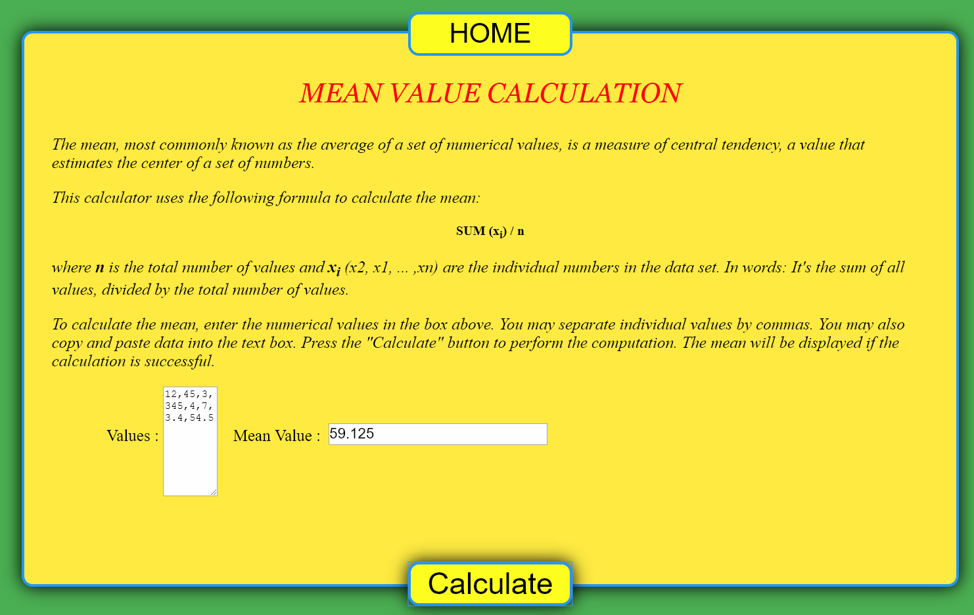
Figure 4.6 – Mean Calculation Page

4.3.2 Slope-Intercept Page :

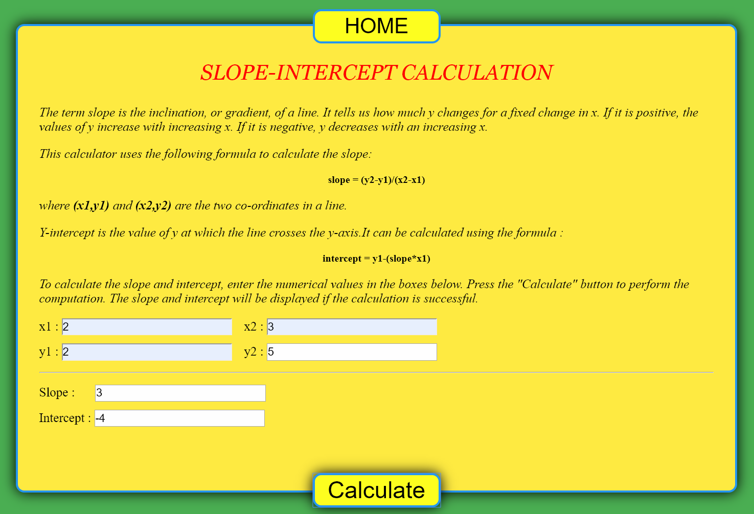
Figure 4.7 – Slope-Intercept Page
4.3.2 Plot For Equation Page :

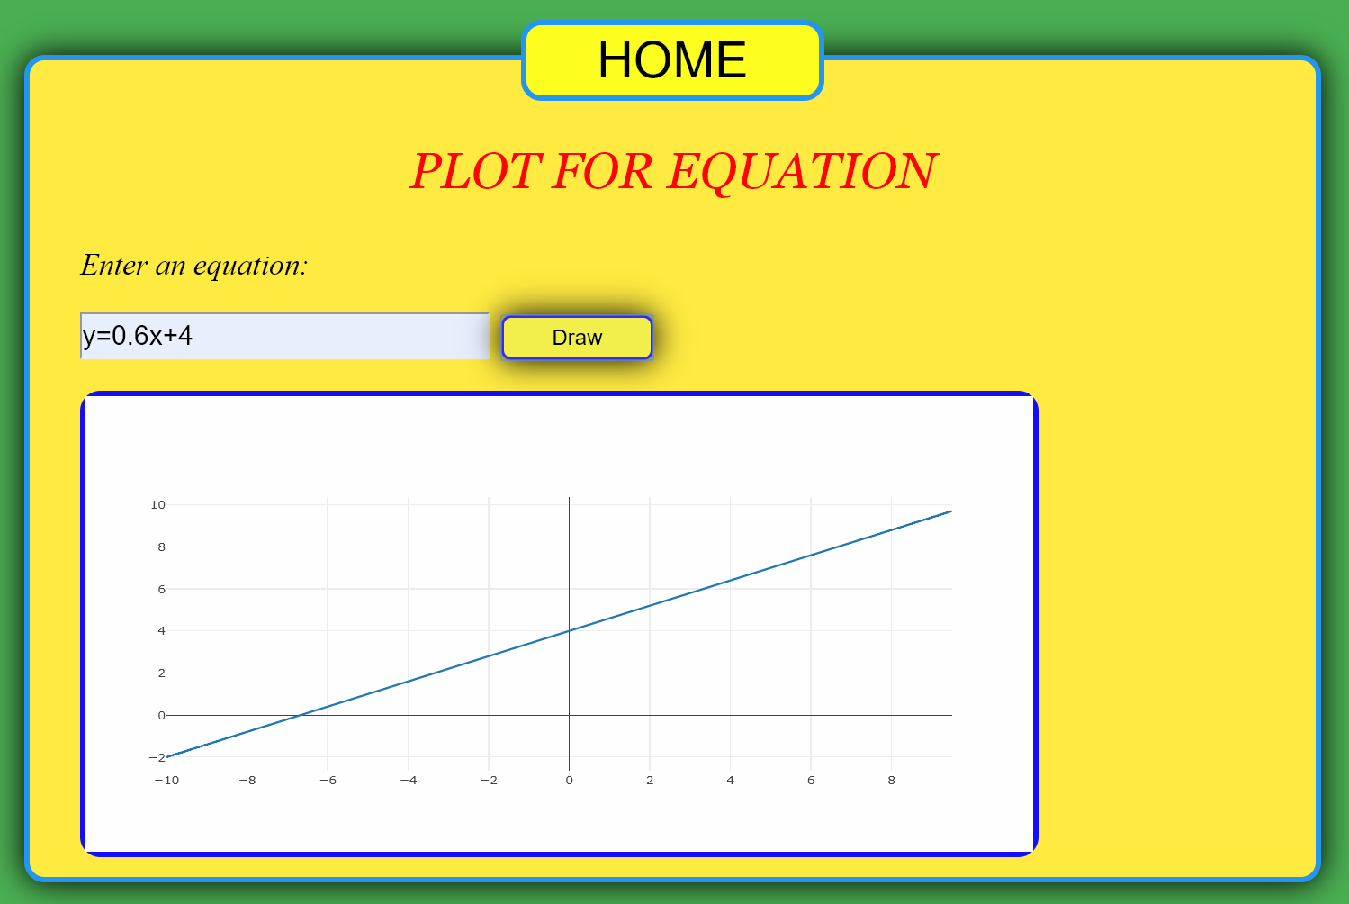
Figure 4.8 – Plot For Equation Page

4.3.2 Linear Regression Page 1 :

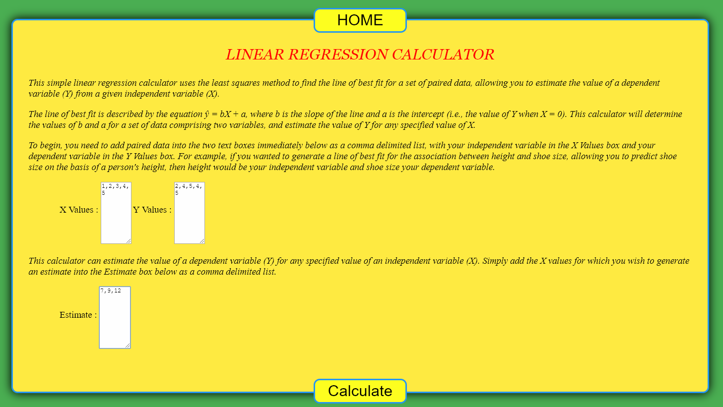
Figure 4.9 – Linear Regression Page 1

4.3.2 Linear Regression Page 2:

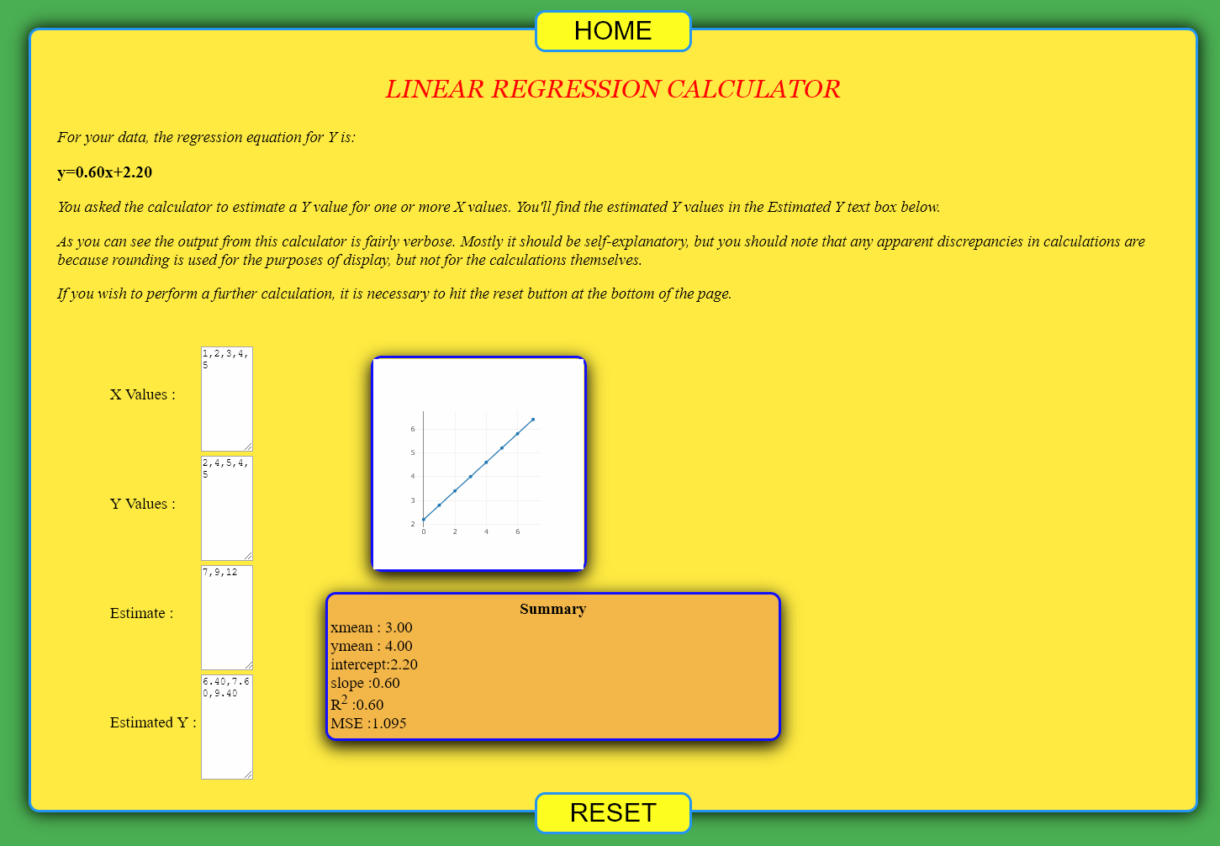
Figure 4.10 – Linear Regression Page 2

4.3.2 Distance-Midpoint Page :

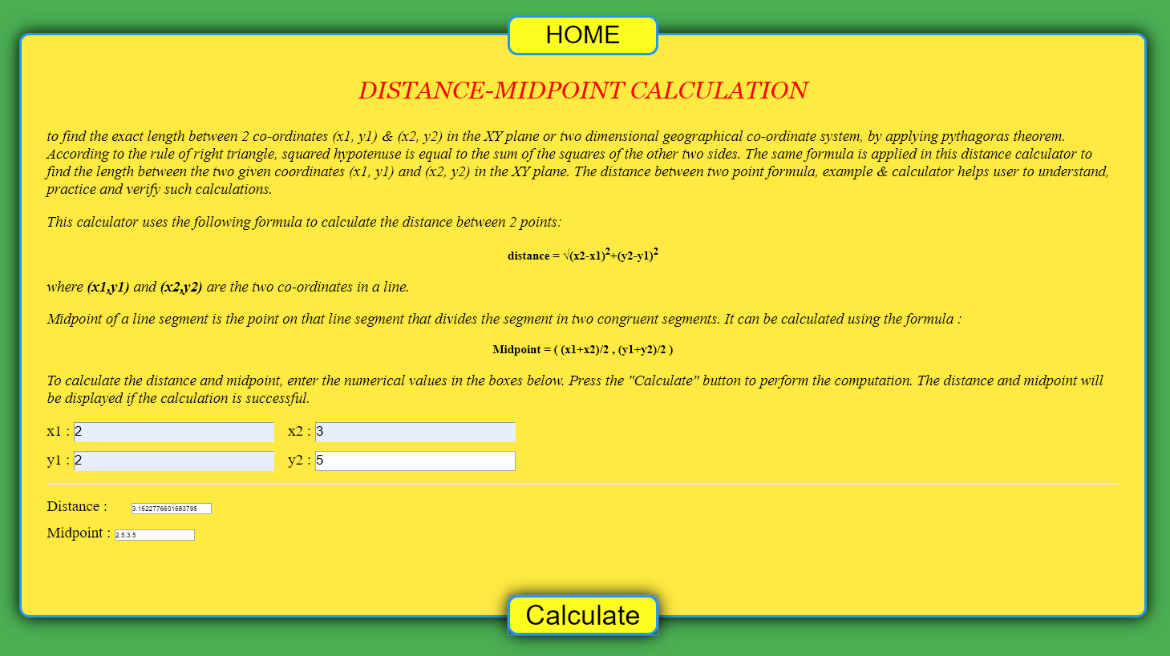
Figure 4.11 – Distance-Midpoint Page
CHAPTER 5
SUMMARY AND CONCLUSION

5.1 SUMMARY
The online calculator is specially for solving the regression problem which is a most common concepts of machine learning.It also performms some other related calculations. Data input to most functions must be pure Cartesian coordinates and variable values. The values should be seperated with commas. Empty cells are not allowed. Coping of data in the textfield is possible. The web pages of the calculator functions also include buttons for viewing a scatter plot of input data. Pressing the button labelled "Calculate" initiates calculation Though, there are ample online calculator for these calculations, but calculator which combines all these calculations with graph plot is hard to find.Since there are lots of datasets with huge amount of data which cannot be easily calculated manually. It takes ample of time to calculate even with normal calculators. So this online calculator solve this problem of calculating large data manually, making it easier, quicker, and more efficient to continue repeating the same things for different dataset we have.

5.2 CONCLUSION
The online calculator introduced above supports a wide range of spatial analysis operations, although, the application is still merely a calculator primarily developed for teaching purposes. The code for all functions used in the online calculator is freely open for assessment, criticism, and development of other applications. This online calculator is specially for solving the regression problem which is a most common concepts of machine learning. The source code for the computational part of the calculator web pages is public, advanced users can see in detail how the result is calculated.
REFERENCES

- Alignments – https://www.stackoverflow.com, March 2019.
- Borders – https://www.tutorialspoint.com, March 2019.
- CSS Attributes – https://www.w3.org/TR/css3, March 2019.
- HTML Tags – https://www.w3.org/TR/html5, March 2019.
- JavaScript – https://www.w3school.com, March 2019.
- Regression Concepts – https://machinelearningmastery.com,
- Matthew MacDonald, "HTML 5 - The Missing Manual", 2nd ed, 2014.
- Sawyer McFarland, "CSS 3 - The Missing Manual", 3rd ed, 2013.

